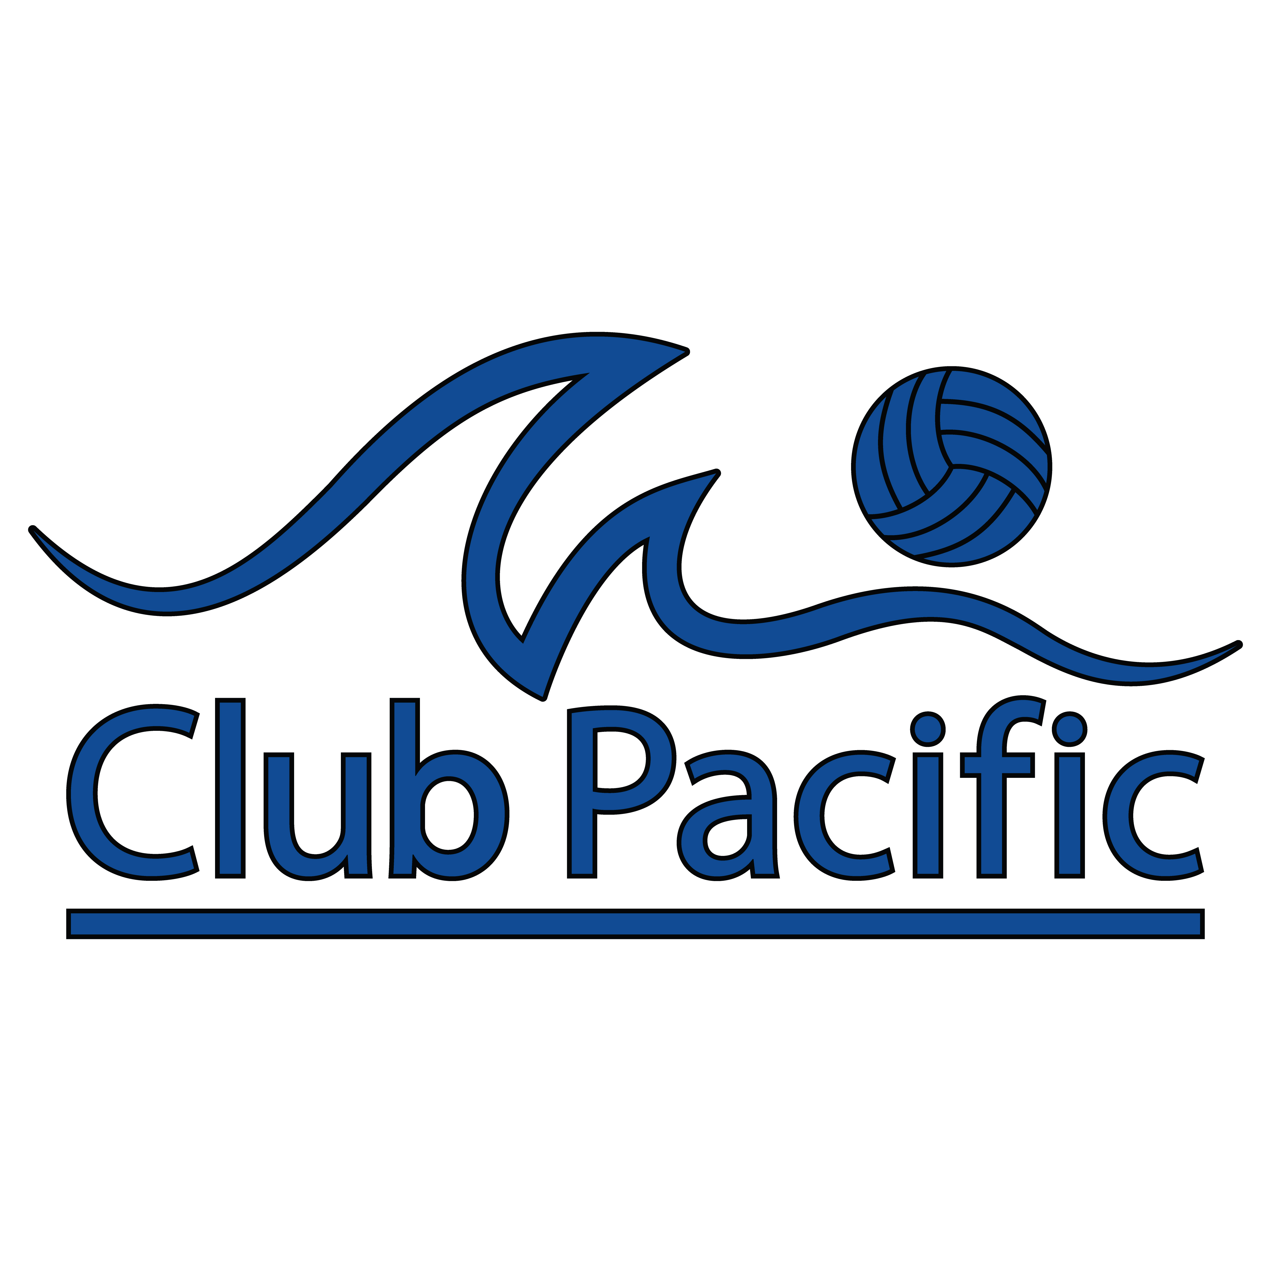
2018 Local Tournament Schedule
12 & Under Open Division
Tournament Date | Age Group | Type | Start Time
Saturday, February 3rd | 12s Open (6th Grade & Under) | Pool Play | 7:30 AM or 1:30 PM
Saturday, February 24th | 12s Open (6th Grade & Under) | Pool Play | 7:30 AM or 1:30 PM
Saturday, March 17th | 12s Open (6th Grade & Under) | Pool Play | 7:30 AM or 1:30 PM
Saturday, April 14th | 12s Open (6th Grade & Under) | Pool Play | 7:30 AM or 1:30 PM
Saturday, May 5th | 12s Open (6th Grade & Under) | Pool Play | 7:30 AM or 1:30 PM
Saturday May 26th | 12s Open (6th Grade & Under) | Pool Play | 7:30 AM or 1:30 PM

Location:

Epic VBC
13955 Stowe Drive
Poway, CA 92064

